Gabriola Fire Protection Improvement District (GFPID)
BOARD OF TRUSTEES
Submitted by GFPID Returning Officer Cheryl Hannebauer

Byelection Report- September 3rd, 2026

Results of the GFPID Byelection 2026

Final Ballot Counts and Standings
Candidate (by votes) | Votes Received
Braid, Jacqui | 469
Cherrington-Kelly, Gregg | 6
Moher, Diana | 94

Ballots Cast: 571 Spoiled: 1 Rejected: 1

On September 3, the poll opened at 11:00 am. The Scrutineer (PB) verified that the ballot box was empty and locked at 10:59 am, when the poll station opened.

The poll closed at 9:00 pm, with the count starting at 9:10 pm and finishing at 9:59 pm. The Corporate Officer, the CO's Assistant, a Member of the Public, and 1 Scrutineer conducted the tally. The Scrutineer verified that the ballot box was empty and that all ballots were counted. Ballots & Tally were Confirmed by GFPID Returning Officer Cheryl Hannebauer.

Candidates must submit any challenges to the byelection within 14 days.
After 60 days, the Returning Officer and the Corporate Officer destroy all byelection materials.

Statistics
Below are some of the forms we are required to fill out at the registration table, as well as some facts about voters. These forms are completed when a voter is referred to the Corporate Officer and/or myself at the registration table by a poll clerk in order to answer a question(s) or resolve an issue.

Statutory Voter Declaration forms
Type of Form | Total
Non-Joint Landowner/ Not joint owners | 2
Voter ID issue (2 last names) | 1
Change of address | 3
Legal Rep (death) | 1
Name change (maiden vs. married name) | 1
Legal Corporation Vote | 3
Property Owners living off island | 1
Not on BCA Roll - No reg owners on property address – changes to BCA in-progress. Owners are to check with BC Assessment to avoid future issues | 2

Poll Clerks (10)
A schedule was created with 6 spares. Due to sickness, scheduling conflicts, etc. 4 of the spares were used. Nine were Poll Clerks from 2 of the previous elections (2025/May 2026); 1 new person was recruited
- 8 of the Poll Clerk workers worked a 5.5-hour shift
- 2 of the Poll Clerk workers did the full-day shift of 10.5 hrs.
- 1 Poll Clerk worker returned & helped with the final count/tally
I sent out an email to all Poll Clerks, thanking them all & asked if they would be willing to be on a list for future Poll Clerk elections; to date, 10 have responded yes for the 2027 Election & future elections.

BUDGET COSTS- $7,500.00 (Budget)
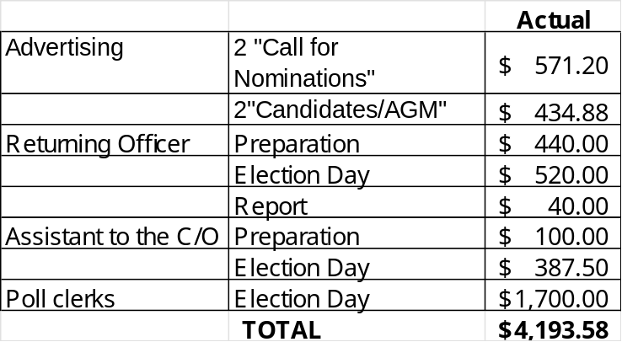
RECOMMENDATIONS (1 A & 2 from May’s election)
Recommendation 1 – Poll Hours
The GFPID Board consider changing General Election Day polling hours from 11:00 a.m.–7:00 p.m. to 10:00 a.m.–6:00 p.m. This would allow election officials sufficient time to complete ballot counting and announce results during the Annual General Meeting without extending the process late into the evening.
- Should this recommendation be adopted, the revised hours should be clearly communicated in all election advertising. Consider changing the advanced polling hours to 9:00 am – 4:00 pm (as there was not much voting traffic after 4 pm). Place a poll on the GFPID Website for public input.

- As requested: that the Polling hours be looked at & discussed with the Board of Trustees, the Corporate Officer & Returning Officer; if changes occur, perhaps an article in the Sounder & a poll on the website to notify the public of the intent.

Recommendation 2 – Deputy Returning Officer
That the Board establish the position of Deputy Returning Officer for future elections to provide succession planning, continuity of knowledge, and transparency in election administration. The Deputy would have the opportunity to shadow the Returning Officer throughout the election process and become familiar with the election procedures and reference binder developed for GFPID by the 2025-2026 Returning Officer, in consultation with the Corporate Officer & Web Designer.

Recommendation 3- Increased Signage
That GFPID increase signage for the Polling station, perhaps with a sandwich board placed on North Road across from the entrance to Church Street and/or large arrows to help direct traffic/the public.

Recommendation 4 - Voter ID
That GFPID review Elections BC rules on acceptable ID (https://elections.bc.ca/voting/voter-id/) and adopt them for future election processes.

The By-Election was conducted in accordance with GFPID election procedures, with appropriate safeguards in place to protect ballot security and maintain transparency throughout the process. Operational observations have been documented to help the Board evaluate future improvements. I appreciate the cooperation of election staff, 1 scrutineer and members of the public in contributing to a successful By-Election.
I would also like to thank the other 3 candidates who came forward to put their name forth for the By-Election process.

Thank-yous- A special thank you to the Corporate Officer, Marjorie, and the Corporate Officer’s Assistant, Amelia, I would also like to thank the poll clerks who came out to help us and went with the flow, especially when the schedule had to be changed a few times due to emerging commitments, illness and cancellations. Thank you to the scrutineer for their observation and participation in the election process. Thank you to the members of the public who came out to exercise their right to vote in the By-election.

Welcome to the newest GFPID Board of Trustees, Jacqui Braid.

