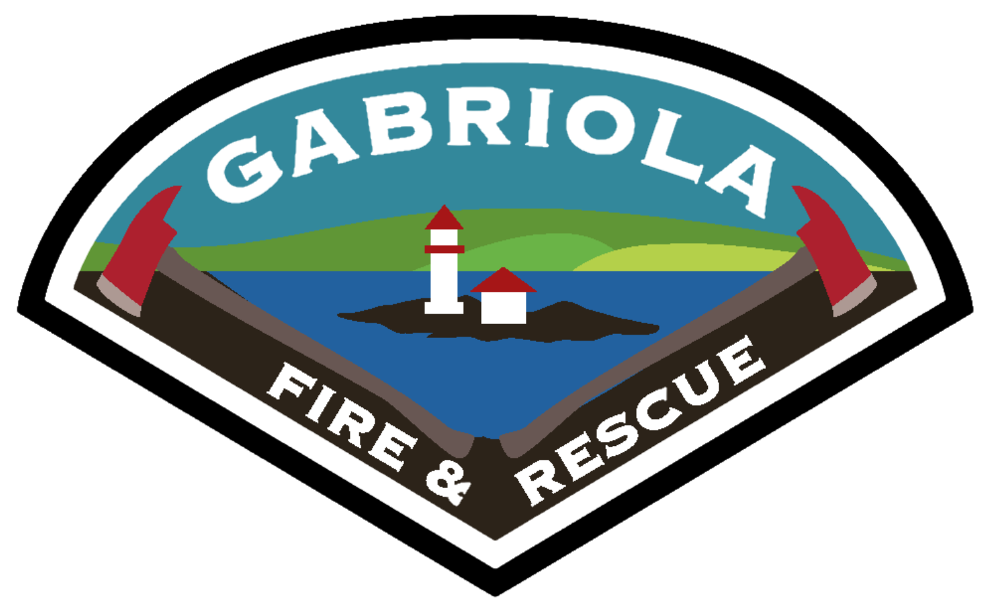
Property Address or Lot number: ______________________________________

Gabriola Volunteer Fire Department
Category 2 Burn Permit

1. Permit validity. Valid only for the location, dates and fire type approved on page 2. Follow GFPID Fire Regulation Bylaw 102 and applicable provincial requirements. The Fire Chief or designate may cancel this permit. No permit overrides a burning prohibition.
2. Water, tools and telephone. Keep adequate water and a working hose or pump ready for immediate use, sufficient to suppress the fire within five minutes. The person tending the fire must have at least one firefighting hand tool and a working telephone.
3. Location and weather. Maintain a fuel break free of combustible material around the fire and safe clearance from buildings, trees and other combustibles. No beach burning. Do not burn when wind could carry sparks beyond the burn area or conditions are unsafe.
4. Permitted material. Burn only seasoned vegetative debris; no tree stumps. Consider chipping, composting or recycling first. Keep soil out of piles. Prohibited materials include tires, plastics, drywall, demolition waste, garbage, asphalt, hazardous or biomedical waste, treated or painted wood, railway ties, manure, rubber, paint, tar paper, and fuel/lubricant containers.
5. Attendance and fire control. Continuously supervise and control the fire until fully extinguished. No smoke, embers or residual heat may remain before leaving, when the permit expires or when directed. If fire escapes the fuel break or becomes uncontrolled, take safe fire-control action and call 9-1-1 immediately.
6. Ventilation and neighbours. Check the forecast for the burn location. Never burn when Poor. Local rules require Fair or Good. Notify neighbors before burning. Do not create harmful smoke or a traffic-visibility hazard; stop adding material if these conditions develop.
7. Smoke-control requirements. Meet the applicable Open Burning Smoke Control Regulation (OBSCR) requirements. Domestic/agricultural burns: material under 3 cm diameter is excluded;
8. Responsibility. The permit holder and landowner remain responsible for the burn, damage, loss and cleanup. Issuing a permit does not transfer that responsibility to GVFD or GFPID.

Rules and current conditions: GFPID Bylaw 102 | GVFD burning rules | BC ventilation index | Full OBSCR

Applicant Information
Date Requested from: ______________________ | Date Requested to: ________________________
Burn location / lot: ____________________________________________________
Property owner: ______________________ | Contractor: __________________________
Mailing address: _____________________________________________________
Primary phone: _______________________ | Secondary phone: ____________________
Email: ______________________________________________________________
Burn supervisor: ______________________ | On-site phone if different: ___________________

Category 2 Burn Checklist
Select one fire type. Confirm the remaining checks before ignition.
☐ | One pile, not exceeding 2 metres in height and 3 metres in width.
☐ | Two piles burning at once, each not exceeding 2 metres high and 3 metres wide.
☐ | Grass or stubble over an area not exceeding 0.2 hectares (2,000 square metres).
☐ | Seasoned vegetation; no stumps or prohibited material; safe fuel break and clearances.
☐ | Adequate water, hose/pump, hand tool, working telephone and continuous supervision.
☐ | No applicable ban; safe wind; ventilation, smoke rules and neighbour notice checked.

Category 3 - Separate Approval Required
This Category 2 permit does not authorize a Category 3 fire. Before a local Category 3 permit is issued, apply to the BC Wildfire Service and obtain an active Open Fire Tracking System (OFTS) burn registration number. Send the number and active-status confirmation to info@gabriolafire.ca. A registration number is not a provincial burn permit; an application alone does not authorize burning.
Apply: BCWS burn registration - online form and instructions | 1-888-797-1717
I own the property or have the owner's authorization. I have read and accept the conditions on both pages. Burn piles may be inspected at the Fire Chief's or designate's discretion.

Applicant signature: __________________________________ Date: __________________

Owner authorization (if applicant is not the owner): __________________________________

Fire Department Use Only
Application / permit no.: _________________ | Inspection date (if required): ______________
Approved from: _______________________ | Expiry date / time: _____________________
Smoke route / zone: ___________________ | Setbacks verified: _____________________
Conditions / water / equipment: __________________________________________
Excavating machinery: ☐ Required as a permit condition ☐ Not required
Fire Chief / designate signature: _________________________ Date: ______________

VALID ONLY WHEN ISSUED AND SIGNED BY GVFD. KEEP BOTH PAGES AT THE BURN SITE.

